**DAILY ONLINE ACTIVITIES SUMMARY**

|  |  |  |  |  |  |  |  |  |
| --- | --- | --- | --- | --- | --- | --- | --- | --- |
| **Date:** | 17-06-2020 | | | | | **Name:** | Anvitha H M | |
| **Sem & Sec** | 4th ‘A’ | | | | | **USN:** | 4AL18CS010 | |
| **Online Test Summary** | | | | | | | | |
| **Subject** | | N/A | | | | | | |
| **Max. Marks** | | 30 | | **Score** | | | - | |
| **Certification Course Summary** | | | | | | | | |
| **Course** | Tableau for beginners. | | | | | | | |
| **Certificate Provider** | | | Great learning academy | | **Duration** | | | 6 hours |
| **Coding Challenges** | | | | | | | | |
| **Problem Statement:** Program in C to count the number that doesn’t contain 3. | | | | | | | | |
| **Status:** Executed | | | | | | | | |
| **Uploaded the report in Github** | | | | | YES | | | |
| **If yes Repository name** | | | | | <https://github.com/alvas-education-foundation/Anvitha-H-M> | | | |
| **Uploaded the report in slack** | | | | | Yes | | | |

**Online test:**

N/A

**Certification course:**

Tableau for beginners.

The course includes detailed explanation on Visualization of maps and charts in tableau and its type and working on parameters in tableau with assessment and quiz on the whole concept of tableau.

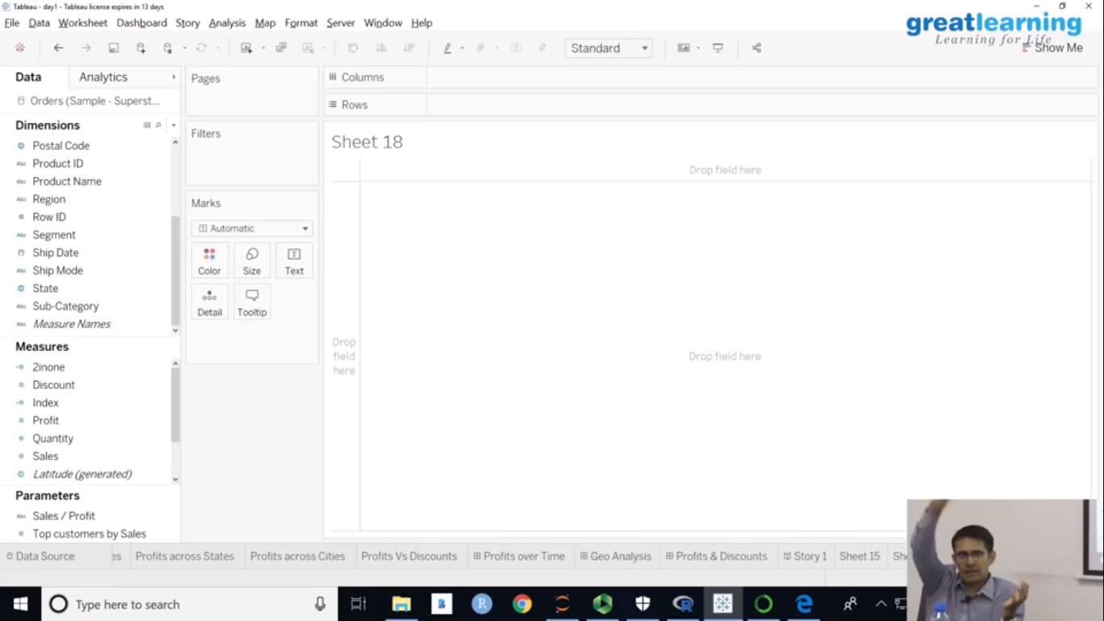

Online coding challenge

The programing statement of the day is

“Program in C to count number that doesn’t contain 3”.

Solution: Executed and uploaded in Github repository.

Link: <https://github.com/alvas-education-foundation/Anvitha-H-M>

